EXPERIMENT-6
OUTPUT:
OUTPUT:
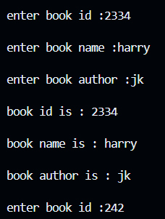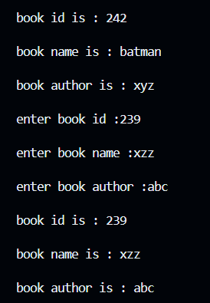

INPUT:
#include <iostream>
using namespace std;
class book
{public:
int book_id;
string book_name;
string author;
void putdata()
{ cout << "\nenter book id :";
cin >> book_id;
cout << "\nenter book name :";
cin >> book_name;
cout << "\nenter book author :";
cin >> author;}
void getdata(){cout<<"\nbook id is : "<<book_id<<endl;
cout<<"\nbook name is : "<<book_name<<endl;
cout<<"\nbook author is : "<<author<<endl;}
};
int main()
{ book b[5];
for(int i=0;i<5;i++){
b[i].putdata();
b[i].getdata();
}
return 0;
}
EXPERIMENT-7
OUTPUT:
OUTPUT:
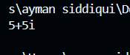

INPUT:
#include<iostream>
using namespace std;
class complex{
float real;
float image;
public:
void putdata(float r,float i){
real=r;image=i;}
void display(){
cout<<real<<"+"<<image<<"i"<<endl;}
friend complex add(complex c1, complex c2);
};
complex add(complex c1, complex c2){
complex c3;
c3.real=c1.real+c2.real;
c3.image=c1.image+c2.image;
return c3;
}
int main (){
complex c1,c2,result;
c1.putdata(2,3);c2.putdata(3,2);
result=add(c1,c2);
result.display();

return 0;
}

